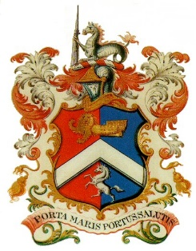
MARGATE CHARTER TRUSTEES
MEETING
MONDAY 20TH JANUARY 2020 – 7.00PM
COMMITTEE ROOM – MEDIA CENTRE

A G E N D A

- Apologies for Absence
- Minutes of Meeting held 2nd December 2019 and Matters Arising
- Mayor’s Report
- Office & Finance Report
- Cash Book (previously circulated)
Propose Exclusion of the public under Section 1(2) of the Public Bodies (Admission to Meetings) Act 1960.
- Budget Proposals 2020-21
- Any Other Business - Mayor’s Fund

