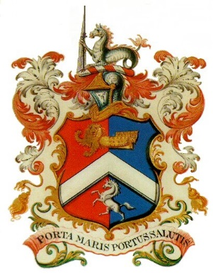
MARGATE CHARTER TRUSTEES
MEETING
MONDAY 15TH JANUARY 2018
COMMITTEE ROOM – MEDIA CENTRE

A G E N D A

- Apologies for Absence
- Minutes of Meeting held 27th November 2017
and Matters Arising
- Mayor’s Report
- Office & Finance Report
- Budget Proposals 2018-2019
- Risk Assessments (update)
- Any Other Business

