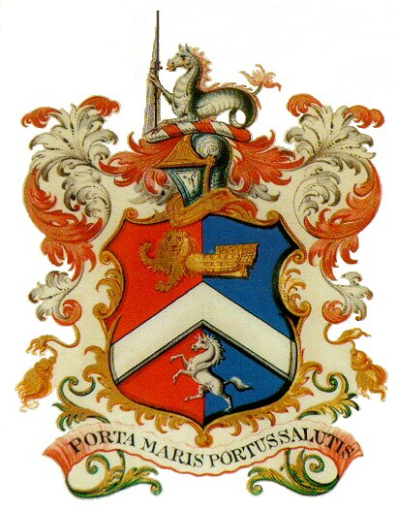
MARGATE CHARTER TRUSTEES
THE MEDIA CENTRE
11-13 KING STREET
MARGATE
KENT CT9 1DA

TELE: 01843 448590
EMIAL: clerk@margate.org.uk

PRIVACY NOTICE

Privacy Notice
When you contact the Margate Charter Trustees
The information you provide (personal information such as name, address, email address, phone number) will be processed and stored so that it is possible to contact you and respond to your correspondence, advise, provide information, send invoices and receipts relating to service provision.
Your personal information will not be shared with any other third party without your prior consent.

The Margate Charter Trustees Right to Process Information
GDPR Article 6 (1) (a) (b) and (c)

Processing is with the consent of the data subject
Or
Processing is necessary for compliance with a legal obligation
Or
Processing is necessary for the performance of a contract with the data subject or to take steps to enter into a contract
Information Security
The Margate Charter Trustees care to ensure the security of personal data. We make sure that your information is protected from unauthorised access, loss, manipulation, falsification, destruction or unauthorised disclosure. This is done through appropriate technical measures and relevant policies.

We will only keep your data for the purpose it was collected for and only for as long as is necessary, after which it will be deleted or shredded.

Your Rights
Access to Information

You have the right to request access to the information we have on you. You can do this by contacting us by email or post. You will be required to provide proof of identity.
Information Correction
If you believe that the information we have about you is incorrect, you may contact us so that we can update it and keep you data accurate.
Information Deletion
If you wish the Margate Charter Trustees to delete the information about you, please contact us.
Right to Object
If you believe that your data is not being processed for the purpose it has been collected for, you may object, please contact us.
Rights Related to Automated Decision Making and Profiling
The Margate Charter Trustees do not use automated decision making or profiling of personal data.
To sum Up
In accordance with the law, we only collect a limited amount of information about you that is necessary for correspondence, information and service provision. We do not use profiling, we do not sell or pass your data to third parties. We do not use your data for purposes other than those specified. We make sure you data is stored securely. We delete all information deemed to be no longer necessary. We constantly review our Privacy Policies to keep it up to date in protecting your data.
Complaints
If you have a complaint regarding the way your personal data has been processed you may make a complaint to our Clerk (DPO) at clerk@margate.org.uk or the Information Commissioners Office: casework@ico.org.uk. Tele: 0303 123 1113

