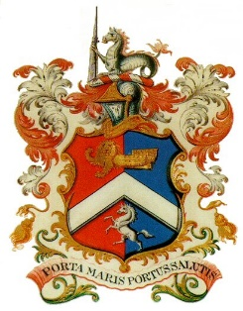
MARGATE CHARTER TRUSTEES
MEETING
MONDAY 25TH JANUARY 2021 – 6.00pm
On-line

A G E N D A

- Apologies for Absence
- Minutes of Meeting held 30th November 2020 and Matters Arising
- Mayor’s Report
- Office & Finance Report
- Cash Book (previously circulated)
- Variances and anticipated outrun (previously circulated)
- Budget Proposals 2020-21
- Review of Standing Orders and Financial Regulations
- Any Other Business - Mayor’s Fund Applications

